INSTRUCTIONS TO Use Apollo:

The web instance of Apollo is running at http://162.243.149.53:8887

Apollo User Guide: http://genomearchitect.github.io/users-guide

TANVEER ANWAR SALIM chr8: 700,001..795,000 MCGJ.8.6 MCGJ.8.6

LOGIN INFORMATION APOLLO

----------------------------------

INSTRUCTIONS:

1. Be sure the right of your genetic engine says

"Valley Oak"

2. Paste chr8 700,001..795,000 into the Annotator search

engine http://162.243.149.53:8887/annotator/index

and enter "Go".

3. Choose one of the genes in the "Annotations"

section to your right. CLICK "Go to Annotation"

4. Find the purple bars that look like this:

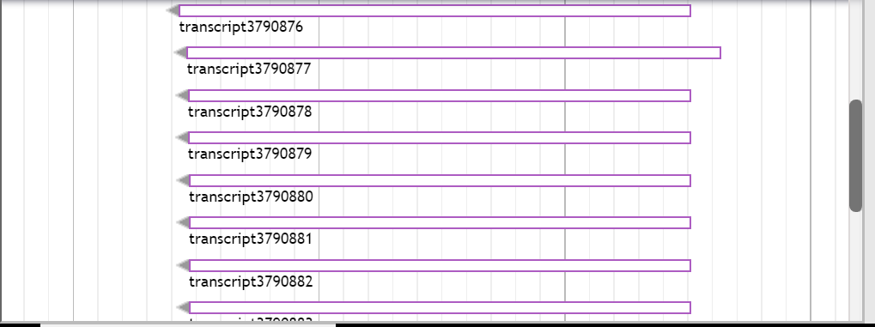

NCBI BLAST: Click on "PROTEIN BLAST"

The web instance of Apollo is running at http://162.243.149.53:8887

Apollo User Guide: http://genomearchitect.github.io/users-guide

TANVEER ANWAR SALIM chr8 700,001 795,000 MCGJ.8.6 MCGJ.8.6

LOGIN INFORMATION APOLLO

----------------------------------

Drag ONE to the top:

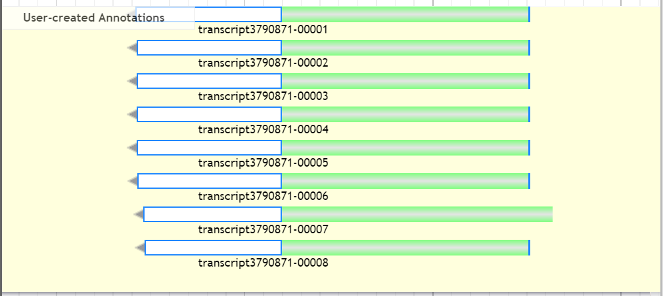

Highlight ONLY ONE OF THEM like this:



Right click on that highlighted and click “Get Sequence”

Copy the genetic code region by using the Snipping Tool:

Make sure “Peptide Sequence” is highlighted

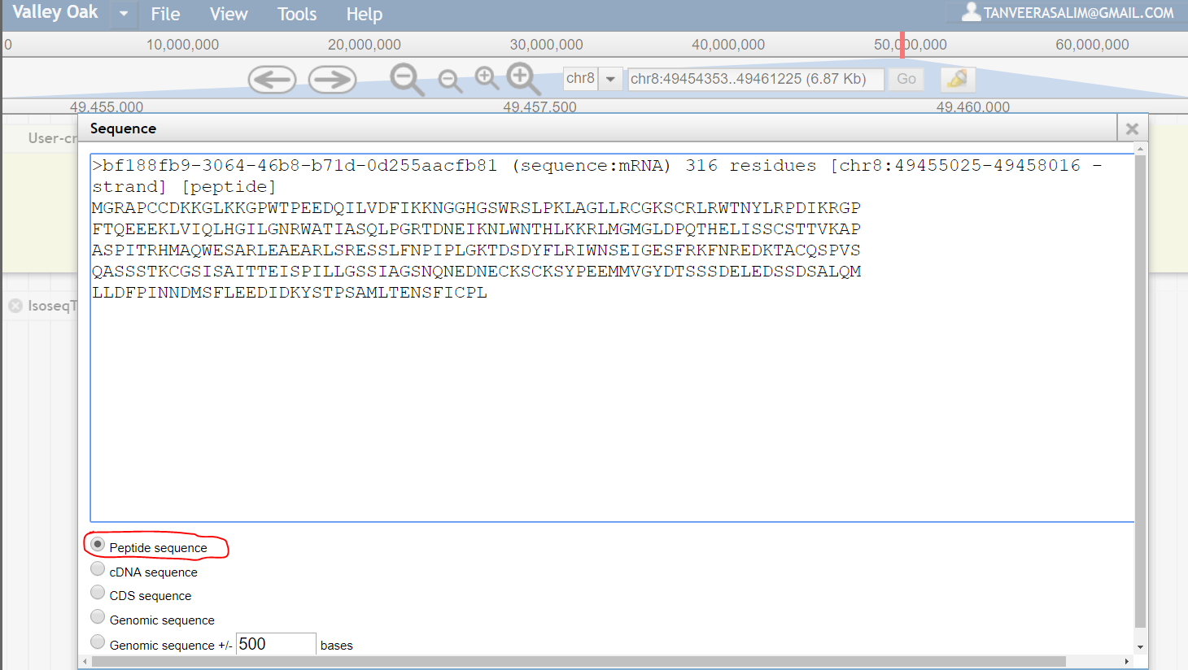

COPY the Peptide coding region using Snipping Tool and Paste it into

“Tanveer Salim MCDB 187AL Research Data”:

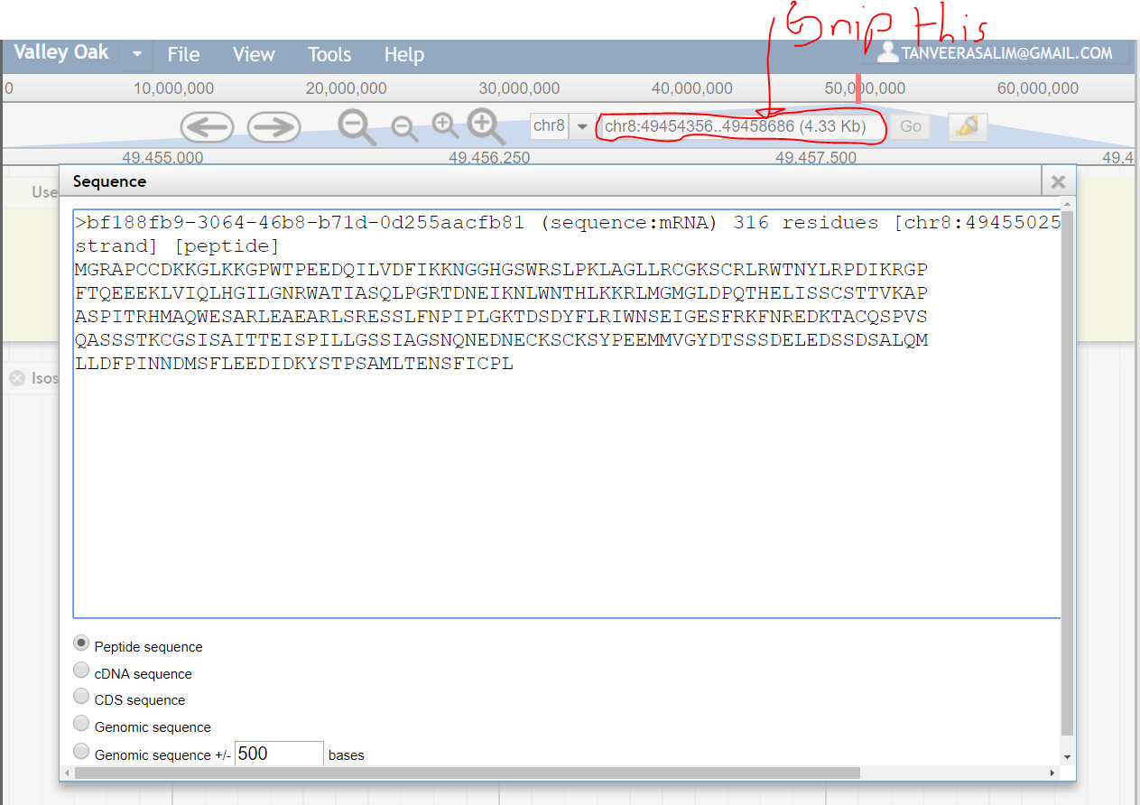

And paste it here AND Follow the Format of the following Picture for the Research Data, POINT OUT IF IT’S A GENOMIC  
OR

**PEPTIDE SEQUENCE**:

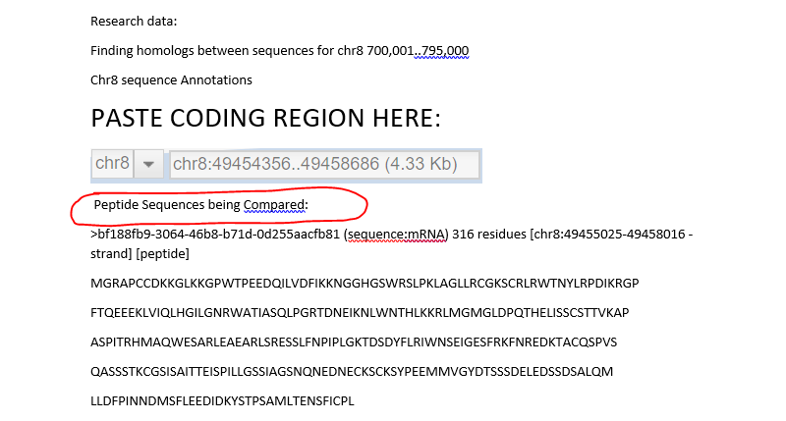

Copy EVERYTHING IN “Sequence” and paste that into the NCBI Peptide Blast.

To get to NCBI Peptide Blast:

1. Go to <https://blast.ncbi.nlm.nih.gov/Blast.cgi>

Click what is Below:

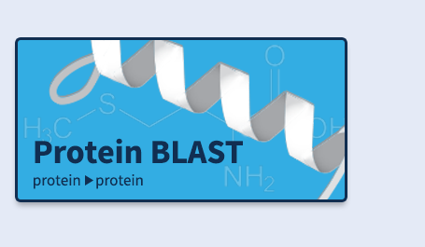

And paste it into the following box. MAKE SURE “blastp” is HIGHLIGHTED BEFORE YOU PASTE:

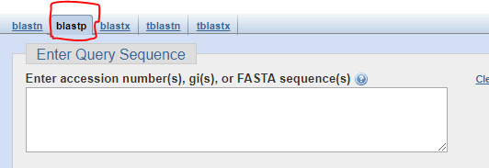

So now it looks like this:

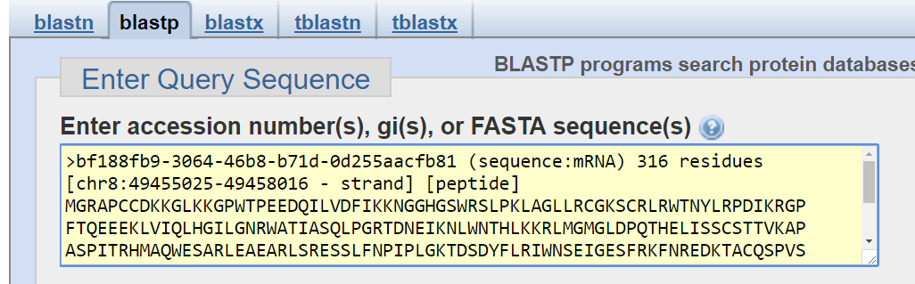

Now CLICK:



That’s this:

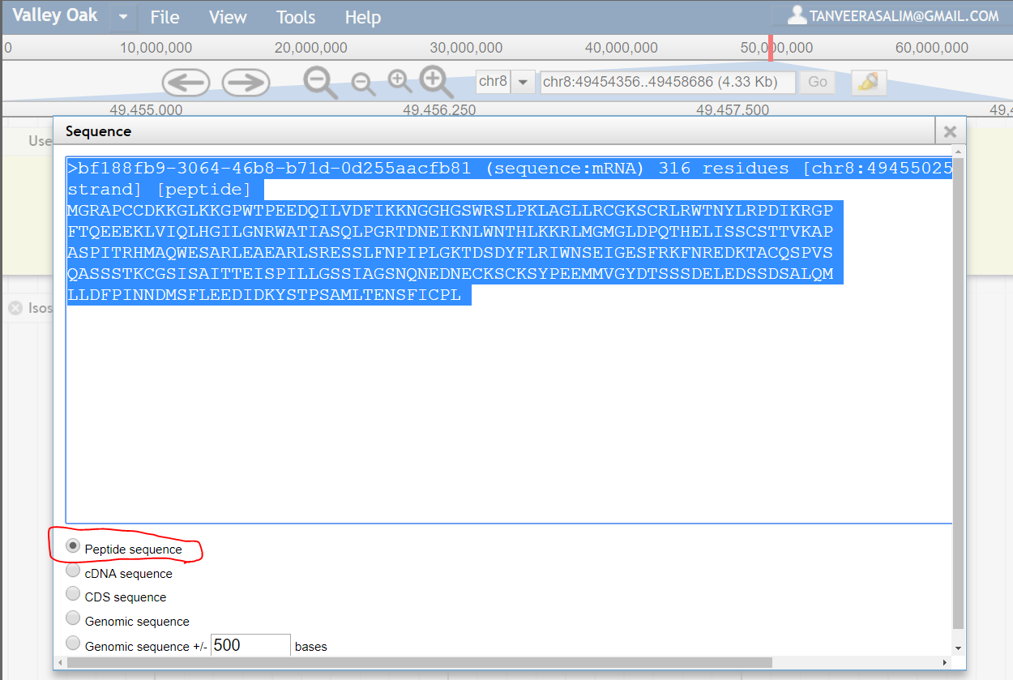

And paste it to BLAST to find protein sequence homologs like this:



Scroll down to **Sequences producing significant alignments:**

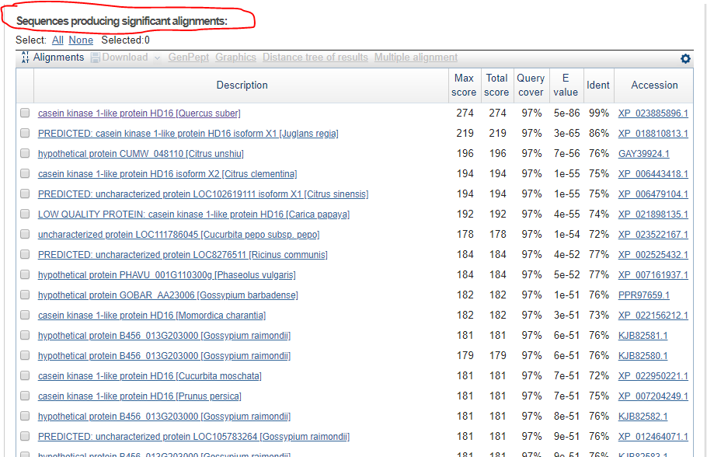

Click on the Accession link for the homolog domain you chose:



Click on FASTA:

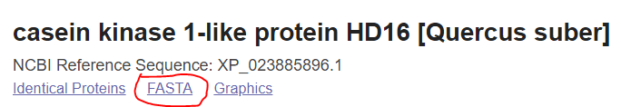

Copy that Sequence HOMOLOG to Clustal Omega:

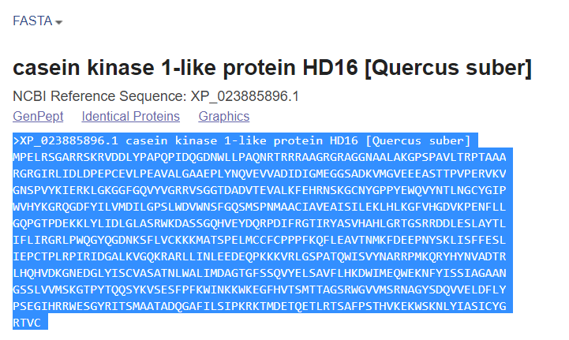

And paste the sequence below the first like this:

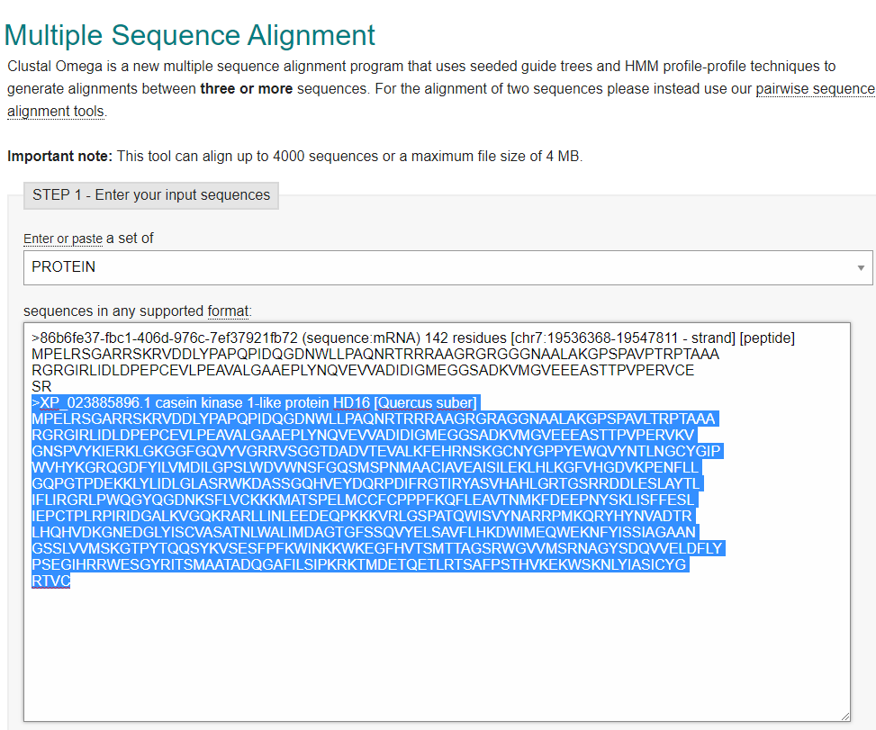

And then click the Submit button:

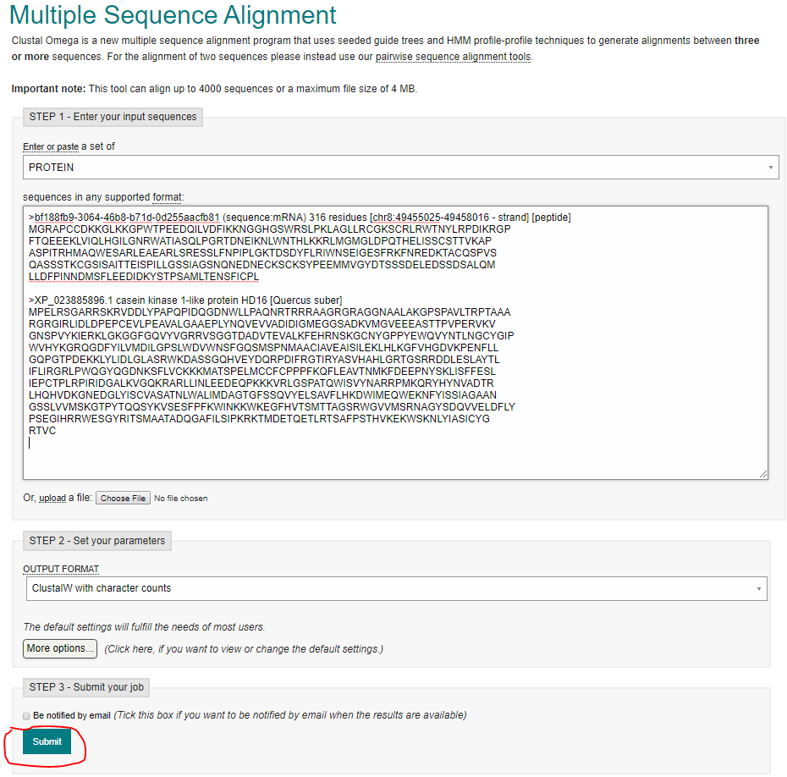

Your Clustal Omega results (hopefully) look like what is below:

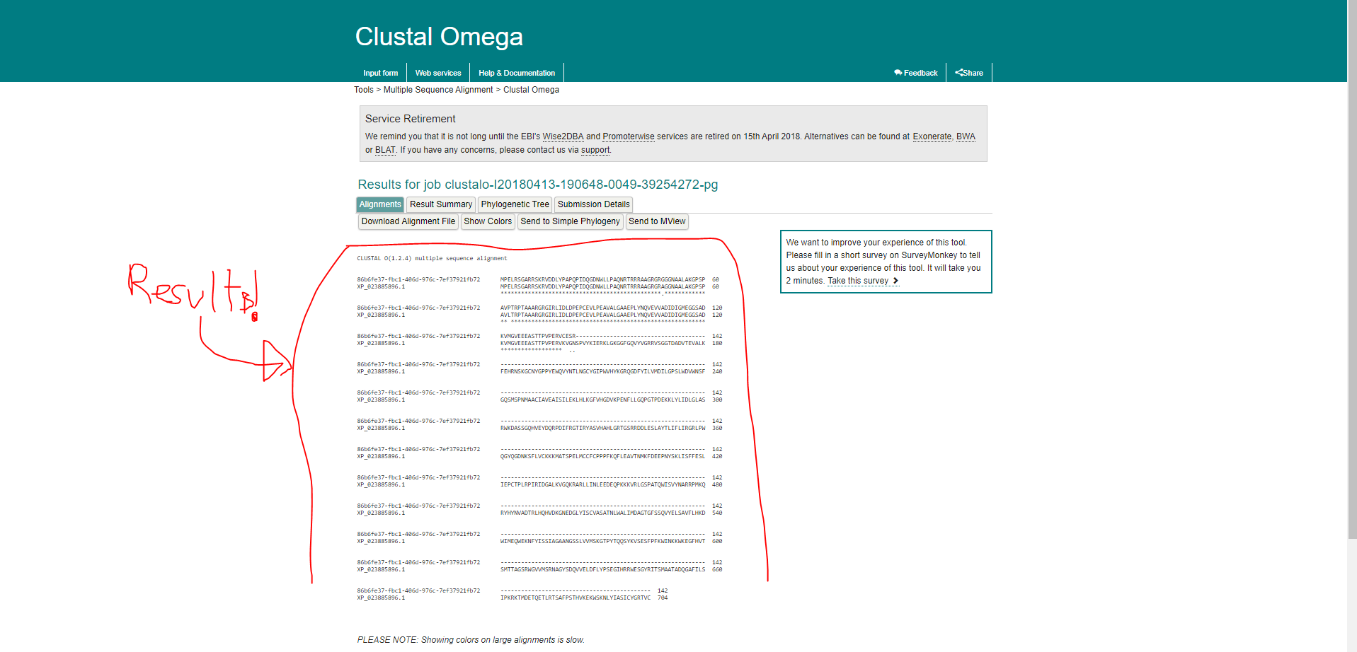

And if not you will have to paste GENOMIC SEQUENCES for each of the sequences

You are comparing INSTEAD of peptide sequences.

Now download the Multiple Sequences Alignment File and

Save it.

Be sure to save the following:

MCDB 187AL Folder in tsalim001 AND UPLOAD IT TO GITHUB BEFORE YOU FINISH

FOR THE DAY

Structural Modeling:

Save the page.

Used to infer functionality of peptide sequences based on localization of peptide sequences?

Finish doing this to ALL OTHER GENES on the Annotations Page. You have plenty left:

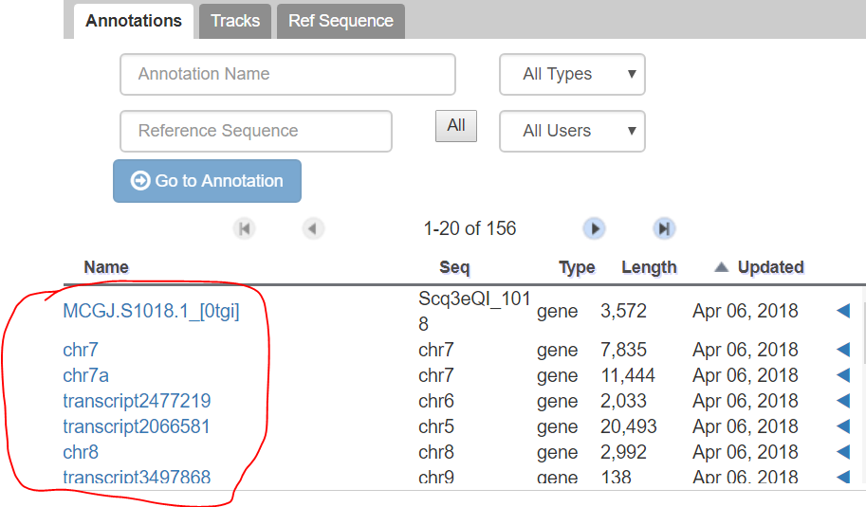

What should we present for MCDB 187AL Presentation Week 3

<https://blast.ncbi.nlm.nih.gov/Blast.cgi#alnHdr_1343964718>